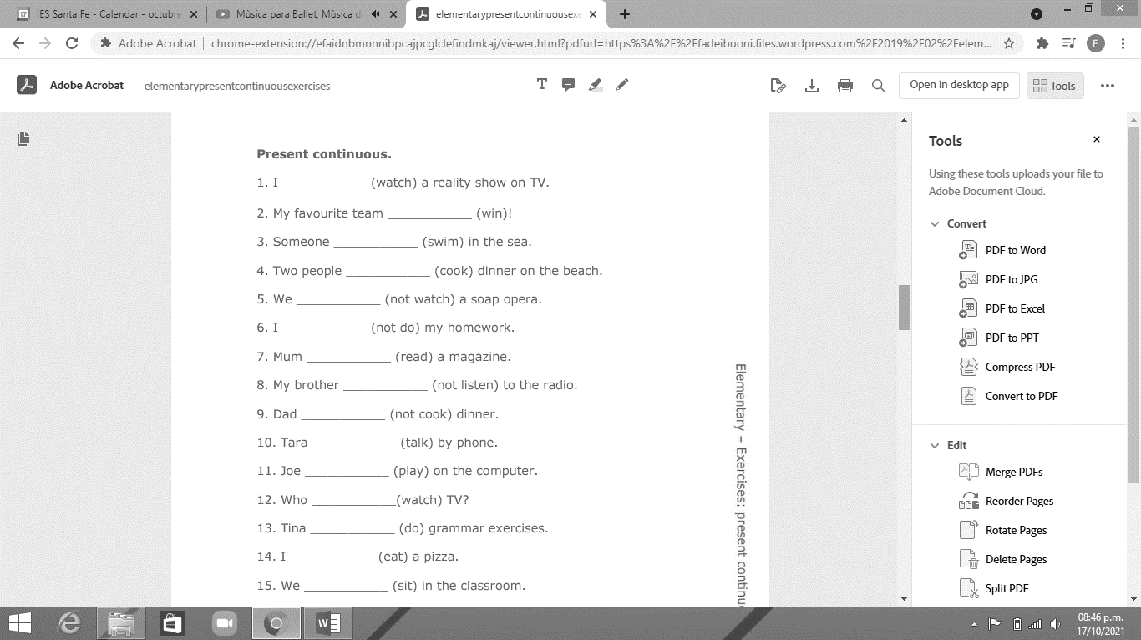
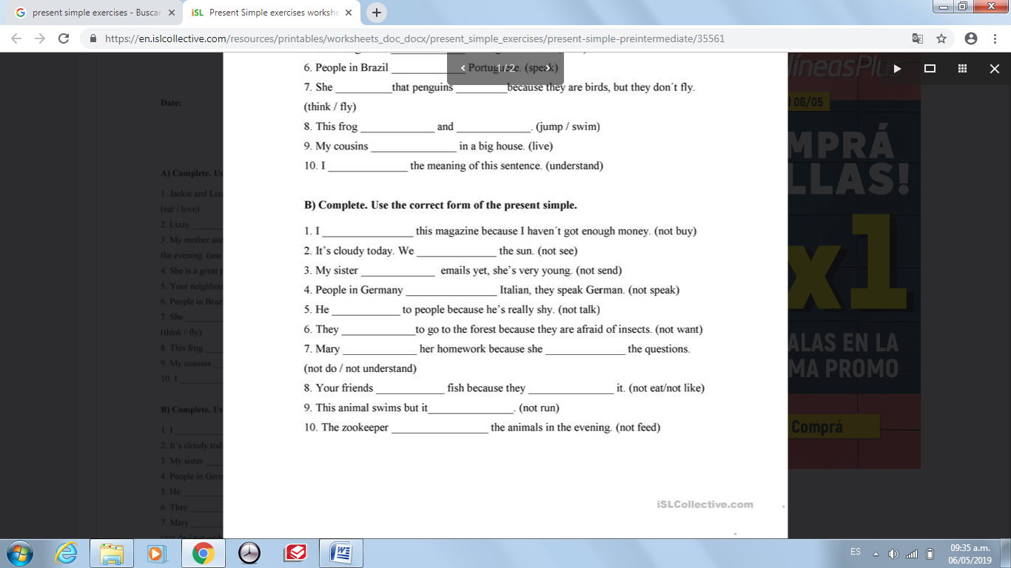

- Put in the verbs in brackets into the gaps. Use the SIMPLE PAST.
1) I ……………………………… my Maths homework yesterday. (do)
2) ………………. Susan ………………………to England by plane? (go)
3) They ………………..……………………….a farm two weeks ago. (visit)
4) Jenny and Peggy ……………………………………………… their brother. (not/ help)
5) The children …………………………….. at home last weekend. (not/ be)
6) When ………......you ………………… this wonderful skirt? (design)
7) My mother…………………………. into the van. (not/crash)
8) The boys………………………………….. the mudguards of their bicycles. (take off)
9) ……………..you ……………………… your aunt last week? (phone)
10) He …………………………………………… milk at school. (not/ drink)

- Complete the sentences with a COMPARATIVE.
1 Mike is ………………………….. (happy) than Sam.
2 Whales are ………………………… (big) than elephants.
3 Gold is …………………………………… (expensive) than silver.
4 Cars are……………………………. (new) than motorbikes.
5 Actors are usually ……………………………….. (famous) than writers.
6 His Italian is …………………………….. (good) than his German.

- Complete the sentences with a SUPERLATIVE.
1. This is …………………….………………..……… (beautiful) time of the year.
2. It's ………………………………………… (expensive) restaurant in town.
3. Martin is ………………………………………. (tall) of the team.
4. Crocodiles are …………………………………………………….. (dangerous) animals here.

- Use either as … as or not as … as in the sentenes below.

Example: Ben Nevis is __________ as Mont Blanc (not/high).
Answer: Ben Nevis is not as high as Mont Blanc.

1) The blue car is…………………………………………………………………. the red car. (JUST/fast)
2) Peter is …………………………………………………………………. Fred. (not NEARLY/tall)
3) The violin is …………………………………………………………………. the cello. (not/low)
4) This copy is …………………………………………………………………. the other one. (ALMOST/bad)
5) Oliver is …………………………………………………………………. Peter. (optimistic)

Look at the difference between "should" and "could".
- You should try yoga.
(=I think that yoga is the best for you.)
- You could try yoga.
(=Yoga is one possibility for you.)

- You…………………………………(study) listening more if you want to improve your English.
- You……………………………. (do) yoga if you want to be healthier.
- He………………………………(quit) his job.
- You………………………..(get) your mom a scarf for her birthday.
- We………………………….(go) to Thailand for the next vacation.
- Mark………………………..(be) more honest.
- They…………………………….. (come) to our house for Christmas dinner.
